|  |  |
| --- | --- |
| **HOME PAGE** | |
| Terreno LAB | Theranostics – Multimodal imaging - Nanoprobes |
| Descrizione ricerca | The research of the group is mainly focused on the design, synthesis, and in vitro/in vivo characterization of contrast agents for diagnostic and theranostic applications at preclinical level.  Besides the use of small-sized paramagnetic Gd(III) complexes, new nanosystems aimed at the MRI visualization of specific biomarker, or drug release have been prepared. Another research line deals with the development of procedures for cellular imaging. |
| Foto personale | Nome file: terreno.jpg |
| Linee di ricerca | Design of targeting imaging probes  MRI visualisation of drug delivery/release  Development of cellular imaging procedures |
| Immagini per linee di ricerca | 1) Figure targeting overview1.jpg,  2) Figure drug release overview 2.jpg,  3) Figure cellular imaging overview 3.jpg |
| Upcoming Events | Indicare la data di inizio dell’evento, la descrizione con il link [www.sito/dell’/evento] con evidenziato in giallo la parola o il testo relativo al link e eventuali figure (figure_events1.jpg, figure_events2.jpg, ...) |
| News | Desrizione delle news, se richiesto, riportare il link come [www.link/della/news]con evidenziato in giallo la parola o il testo relativo al link e eventuali figure (figure_news1.jpg, figure_news2.jpg, …) |
|  |  |
| **RESEARCH OVERVIEW** | |
| Linee di ricerca | 1) Design of targeting imaging probes  This research aims at developing imaging probes conjugated with vectors able to specifically recognize a disease marker.  (Figure targeting overview1.jpg)  2) MRI visualisation of drug delivery/release  MRI can offer the opportunity to visualize the release of the material entrapped in a nanocarrier  (Figure drug release overview 2.jpg)  3) Development of cellular imaging procedures  Tracking cells by in vivo imaging is a powerful tool in cellular therapies  (Figure cellular imaging overview 3.jpg) |
|  |  |
| **RESEARCH LINE #1** | |
| Titolo generale | Design of targeting imaging probes |
| Introduzione generale | Active targeting is one of the most used approaches in pharmaceutical field in order to improve the concentration of a molecule (therapeutics or in vivo diagnostics) at the pathological site. Therefore, a targeting agent is a molecular system containing the “active principle” (a drug or an imaging probe) conjugated to a vector that has to exhibit a high affinity and specificity towards the biological target (cellular receptors, intracellular markers, enzymes, metabolite, extracellular components,…). Moreover, the success of the approach is also based on the accessibility of the biological target by the targeting system. The design of a targeting imaging probe is affected by the sensitivity of the imaging modality. For instance, to overcome the relatively low sensitivity in the contrast detection of MRI, the targeting vector is conjugated to macromolecular or nanosized systems loaded with a high number of imaging units in order to significantly increase the contrast delivered at the biological target. On the contrary, in case of Optical or Nuclear imaging, sensibility is much better and a single fluorophore/radioisotope can be sufficient to generate enough signal from the disease marker.  Considering the accessibility issue, MRI targeting agents are very suitable for endothelial markers that do not require the extravasation of the “large” probe, whereas optical probes can easily reach extracellular and intracellular targets. |
| attività specifica/specifiche | MRI visualization of inflammation by paramagnetic micelles decorated with an anti VCAM-1 peptide.  This activity deals with the synthesis of mixed micelles composed by DSPE-PEG2000 and the amphiphilic Gd(III) complex GdDOTAMA(C18)2. The micelles were decorated with a cyclic peptide known to have a high affinity towards the endothelial receptor VCAM-1, which is overexpressed in presence of inflammation. In order to be loaded into the micelles the peptide was conjugated to a phospholipid.  Inserire research_1_1.jpg  Paramagnetic mixed micelles targeting VCAM-1 displayed a hydrodynamic diameter of 20 nm with a PDI of 0.2. The millimolar longitudinal relaxivity (r1) at 0.5 T was 34.9 s−1mmolGd−1 at 25 °C and 35.3 s−1mmolGd−1 at 37 °C. The relaxivity was also measured as a function of the proton Larmor frequencies (from 0.01 to 70 MHz):  Inserire research_1_2.jpg  The obtained NMRD (Nuclear Magnetic Relaxation Dispersion)  profile is characterized by a relaxivity hump at ca. 20−  30 MHz, a feature that clearly indicates the occurrence of a restricted rotational motion for the paramagnetic Gd-complexes  in the micelles.  The performance of this targeting system has been successfully tested on a mouse model of peripheral inflammation (Pagoto A. et al, 2016, doi:10.1021/acs.bioconjchem.6b00308), and on a mouse model of neuroinflammation (Garello F. et al, 2017, doi.org/10.1016/j.nano.2017.10.002).  The peripheral inflammation was generated by injecting lipopolysaccharide (LPS) in the mouse leg skeletal muscles. Conventional H&E (hematoxylin and eosin) histology confirmed the extensive infiltration of monocytes,  lymphocytes, and neutrophils in the leg 48 h after LPS injection  Furthermore, immunofluorescence experiments confirmed the expression of VCAM-1 receptors in the inflamed muscle.  Forty-eight hours after the induction of inflammation, the  paramagnetic micelles (containing the targeting or a scrambled untargeted peptide) were injected intravenously in the tail vein  at a Gd dose of 55.0 μmol/kg bw. Then, the animals (n = 6)  were scanned by MRI (at 1 T) over a period of 24 h postinjection.  A T1 contrast enhancement around 45% was observed in the inflamed region 4 h post-injection The contrast measured in the inflamed leg was ca. 5-fold higher than the enhancement detected in the contralateral healthy leg, and 2-fold higher than the response measured upon administration of the control micelles functionalized with the scrambled peptide. The MR images reported below show  that 4 h after the injection of the micelles, a hyperintense signal  was visible in the inflamed leg (red circle), while no brightening  was detected in the control experiment.  Inserire research_1_3.jpg  The accumulation of the MRI agent in the legs was confirmed by ICP-MS analysis, which showed that the amount of metal ion in the inflamed muscles after the injection of the VCAM-1-targeted micelles was ca. 40% higher than the amount found in the diseased tissue after the injection of the control micelles loaded with the scrambled peptide and ca. 3-fold higher with respect to the Gd found in the healthy muscles regardless of the type of micelles injected.  Inserire research_1_4.jpg  The neuroinflammation model was prepared through a local injection of (LPS) in the right striatum. The presence of inflammation and the over-expression of VCAM-1 in the involved hemisphere were detectable already 24 h after surgery by ex-vivo histology, whereas no hallmarks of inflammation were present in the contra-lateral hemisphere. The animals were enrolled in the study 24 h after LPS injection, received intravenous administration of VCAM-1 targeted micelles (0.05 mmolGd/kg bw) and were imaged at 1.0 T at 20 min, 4 h, 24 h and 48 h post injection to monitor micelle homing to the site of inflammation.  Inserire research_1_5.jpg  The T1 signal enhancement calculated over pre-images, reached a peak value 24 h post micelle injection, with a statistically significant difference between diseased and healthy hemispheres.  To ascertain the specificity of the administered nanosystem, a  comparison with micelles bearing the untargeted scrambled  peptide was conducted. The results obtained displayed a  statistically significant difference in the % T1-SE of the inflamed  striatum between targeted and non-targeted micelles at 24 h p.i.  (39.3 ± 4.4 vs. 18.9 ± 2.2%, respectively, ANOVA P values =  0.003.  Inserire research_1_6.jpg  At the other time points, no statistically significant differences between the two nanosystems were detected.  Interestingly, the kinetic of the contrast enhancement observed for the two nanosystems was a bit different, with the targeted system that performed much better after 24 h post-injection, whereas at 48 h the two micelles showed a very similar effect. Most likely, this observation is an indirect demonstration of the effective targeting of the VCAM-1 directed system, and it suggests that the targeting to the receptor (though, likely, it is not the only process accounting for the accumulation of the probe in the inflamed area) is a faster event than the passive accumulation occurring for the untargeted micelles.  The signal obtained 24 h post injection of the scrambled micelles  was definitely comparable to the T1-SE detected 20 min after the  administration of the contrast agent MultiHance (13.4% ± 2.7%),  which is clinically employed to evaluate the presence of alterations in blood brain barrier permeability. This finding suggests that the  contrast obtained after the administration of scrambled micelles is  mainly related to passive extravasation, thus further supporting the  view that VCAM-1 targeted micelles effectively bind the corresponding target in vivo. |
| **RESEARCH LINE #2** | |
| Titolo generale | MRI visualisation of drug delivery/release |
| Introduzione generale | The design of imaging procedures aimed at providing pharmacologists/ clinicians a valuable in vivo and minimally-invasive support to visualize the effective delivery and release of a drug in the diseased region is very crucial to improve the efficiency of a pharmacological therapy and to optimize the therapeutic planning on an individual base (personalized medicine). This research area, which is part of theranosis, requires the development of chemicals that have to generate an imaging response as a function of the delivered and/or released drug. In  principle, imaging protocols for the visualization of drug delivery can be designed for almost all the available imaging modalities (nuclear, CT, optical, US, MRI, and hybrid technologies). However, for imaging drug release purposes, MRI is certainly the choice of election because of the widespread and successful preclinical and clinical use, the good spatio-temporal resolution, the possibility to reach deep tissues/organs without any limitations, and the rich portfolio of agents and contrast modalities available.  The motivation of using nanocarriers in the pharmacological field is mainly driven by the necessity to improve the therapeutic index of a drug. The rational is to influence the biodistribution of the drug to favour (by passive or active targeting) the accumulation and availability at the target organ, thereby improving therapeutic efficacy and reducing side effects. However, to exert the effect, the drug needs to be released from the carrier. For the nanomedicines currently approved for clinical use, this fundamental step occurs spontaneously, i.e. following the natural degradability of  the nanocarrier interacting with tissue components.  However, a significantly better control of the release can be achieved through a specific stimulation, especially suitable for treating solid tumours.  The release of a drug is dependent on many factors, including the physico-chemical properties of the nanocarrier, and therefore, the development of new drug delivery systems is still an important research area. |
| attività specifica/specifiche | MRI visualization of the release of doxorubicin from liposomes stimulated by local application of ultrasound  The release of a drug from a nanocarrier can be stimulated by several factors, endogenous (e.g. pH, enzyme), or externally applied (heat, light, US..).  It has been demonstrated that liposomes can release their  content upon stimulation with pulsed low intensity non-focused US (pLINFU), which can be broadly defined as pulsed, planar, acoustic waves with intensity lower than 10 W/cm2 and US frequencies ranging from low (20 kHz) to therapeutic (1–3 MHz) frequency. The lower energy associated with pLINFU produces minimal or no thermal effects and the release of the drug mainly results from the mechanical interaction between the acoustic waves and the nanocarrier.  A practical approach to visualize by MRI the release of the drug from liposomes consists of encapsulating a hydrophilic paramagnetic agent (based on Gd3+ or Mn2+ ions) in the aqueous inner cavity of the nanovesicle. Upon the entrapment, the MRI contrast is “silenced” and its activity is recovered when the agent is released.  Inserire research_2_1.jpg  In the first paper (Giustetto P. et al. 2013, DOI: 10.1166/jmihi.2013.1183), it has been demonstrated that the release of the imaging probe is strongly dependent on the pulse repetition frequency of the insonation (main US frequency 27 kHz) and it is even affected by subtle changes in the chemical composition of the nanocarrier.  Inserire research_2_2.jpg  A step forward was achieved later on (Rizzitelli S. et al. 2014, DOI:10.1016/j.nano.2014.03.012) when the US stimulation (3 MHz) was applied *in vivo* on a subcutaneous melanoma mouse tumour. In addition to the contrast enhancement observed in the tumour after the US stimulation, a strong evidence about the effective release of the agent was gained by the detection of the T1 contrast enhancement in kidneys and bladder. In fact, since gadoteridol has a rapid renal excretion (t1/2 of ca. 3 hours in mice), the higher contrast observed in both organs for the Gd+/US+ group supports the remote release of the agent.  Inserire research_2_3.jpg  To test the therapeutic potential of this approach, liposomes were co-encapsulated with the drug doxorubicin and tested on a mouse model of breast cancer (Rizzitelli S. et al. 2015, DOI: 10.1016/j.jconrel.2015.01.028 ). First of all, it was checked that the release of the two components (the imaging probe and the drug) were similar in order to consider the contrast enhancement as a good predictor for the drug release. The results confirmed the strong dependence of the release on the pulse repetition frequency, and, very important, highlighted the close similarity in the release  of the two compounds over the entire range investigated.  Inserire research_2_4.jpg  The planning of the experiment is reported below:  Inserire research_2_5.jpg  The liposomes were administered once a week for three weeks and the US stimulation was locally applied after each administration. MRI were carried out more frequently the day of the administration and then once a day.  pLINFU-stimulated mice showed significantly higher T1 contrast  than the untreated group, as expected in case of successful release of the MRI agent. The enhancement for the US-group was maximal just after the stimulation and decreased within 6 h. Contrarily, a much smaller enhancement was detected in the NoUs-Group, which was due to the intratumour circulation of the intact “MRI-quenched” liposomes.  Inserire research_2_6.jpg  As expected from the renal excretion of the MRI agent,  the release of the agent in the tumour is associated with the accumulation of the probe in the kidney calyx and bladder. The presence of a very bright T1 contrast in both of these compartments just after the tumour insonation was a clear evidence of the effective intratumour release of the MRI probe triggered by the local pLINFU application.  Inserire research_2_7.jpg  As further proof of the effective release of doxorubicin in the tumour stimulated by pLINFU, confocal fluorescence microscopy slices of tumour treated showed a diffuse red fluorescence form the drug, whereas in the untreated tumour the fluorescence was much more localized.  Inserire research_2_8.jpg  Importantly, the tumour of the mice stimulated with pLINFU after three weeks of treatment grew significantly less with respect to the untreated animals and the controls (that did not receive liposomes).  Inserire research_2_9.jpg  A further improvement in the therapeutic outcome was achieved by adding a second acoustic stimulus before that one applied for triggering the release of the drug (Rizzitelli S. et al., 2016, DOI: 10.1016/j.jconrel.2016.03.040). This second pulse was designed to induce sonoporation, *i.e.* to permeabilize cell membrane with the aim of increasing the total amount of drug that diffuses in the tumour. The gain in the therapeutic performance of this improved method was excellent, and the combination between release and sonoporation led to a complete remission of the tumour after the three weeks of treatment.  Inserire research_2_10.jpg  Among the new nanocarriers explored for improving the imaging and pharmacokinetic properties, dendrimersomes have displayed interesting results.  Dendrimersomes are self-assembling nanovesicular systems consisting of a double-layer membrane made up of amphiphilic dendrimers like that one shown below:  Inserire research_2_11.jpg  Inserire research_2_12.jpg  Filippi et al. 2014 (DOI: 10.1039/c3cc49584a) demonstrated the versatility of dendrimersomes to be loaded with MRI agents either hydrophilic (Gadoteridol) or amphiphilic (Gd-DOTAMA(C18)2).  The relaxivity of the system loaded with the amphiphilic complex was similar to liposomes, whereas the relaxivity of the system loaded with Gadoteridol was higher than that observed for conventional liposomes, demonstrating the high water permeability of the dendrimersomes membrane.  The stability and biocompatibility of a series of four dendrimersomes consisting of two amphiphilic dendrimers reported in literature and two lower-generation amphiphilic dendrimers synthesized ex-novo (in collaboration with prof. L. Tei, UniUPO) were compared in detail by Filippi M. et al 2015 (DOI: 10.1039/c5nr02695d). The new dendrimers were able to form dendrimersomes with low polydispersion and highest stability. Furthermore, no signs of cytotoxicity and changes in proliferation rate were observed even after 48 hours of incubation with different cell lines (RAW 264.7, J774.A1 and NIH/3T3). Finally, the more stable formulation of dendrimersomes was injected into a healthy mouse (first *in vivo* experiments for this class of nanocarriers) to evaluate plasma half-life. The value obtained, around 70-80 min, was very similar to that one obtained injecting conventional liposomes. |
|  |  |
| **RESEARCH LINE #3** | |
| Titolo generale | Development of cellular imaging procedures |
| Introduzione generale | Tracking cells *in vivo* by using imaging approaches represents a reliable method to assess the characteristics of cell grafts and to monitor their fate after transplantation. In that respect, minimally invasive techniques with high spatial resolution are desirable with a view of implementing therapeutic protocols in the clinical ordinary. MRI is a leading imaging modality enabling the non-invasive visualization of cell populations and their movements after transplantation in living animals with superb resolution. In order to be detectable, cells require to be adequately labelled with MRI contrast agents (CAs). Due to their excellent imaging efficiency, the superparamagnetic iron oxide nanoparticles (SPIONs) are regarded as the gold standard in cell-labeling. However, some issues  are associated with their contrast generation mechanism based on signal-loss (negative contrast). As a promising alternative, paramagnetic CAs based on the metal Gadolinium (Gd) create a contrast increment (positive contrast) in T1-weighted (T1w-) images, overcoming several complications related to the use of SPIONs. Even if toxic in the form of free aqueous ion, Gadolinium is generally considered safe when administered as a macrocyclic chelate and several agents have been approved for the clinical use so far. Differently from magnetic nanoparticles, large amounts of paramagnetic small molecules have to be delivered to target sites in order to be detected, and several labeling procedures have been developed to achieve this goal.  In addition to Gd(III)-complexes, also fluorinated nanoparticles represent a valuable option for cellular imaging, especially for the visualization of the macrophage recruitment in inflammation sites or to tracking dendritic cells. One of the advantages of 19F-MRI is the possibility to quantify the signal and calculate the cellular content in the site of interest.  Besides MRI, other imaging modalities can be used for tracking cells in vivo, like optical or photoacoustic imaging. |
| attività specifica/specifiche | **MRI tracking of MSCs labeled with Gadoteridol in a Spinal Cord Injury experimental model**  In this activity, Filippi M. et al., 2016 (DOI: /10.1016/j.expneurol.2016.05.023) labelled murine Mesenchymal Stem Cells (MSCs) with the clinically approved MRI agent  Gadoteridol through a procedure based on the hypo-osmotic shock. Cells were successfully tracked *in vivo* in a murine model of Spinal Cord Injury (SCI).  Inserire research_3_1.jpg  The hypo-osmotic shock method (Di Gregorio E. et al, 2013) allowed the internalization of a higher number of contrast agent units than the conventional isotonic labeling.  Inserire research_3_2.jpg  Furthermore, also the T1 contrast enhancement of Gadoteridol internalized using the hypo-tonic method is higher than the isotonic technique.  Inserire research_3_3.jpg  The differences observed *in vitro* were confirmed *in vivo* after transplantation of a different number of cells in a mouse model of spinal cord injury.  Inserire research_3_4.jpg  Interestingly, the injected cells migrated from the injection site to the lesion site, and MRI was able to visualize this movement.  Inserire research_3_5.jpg  Very important, the diseased mice treated with the labelled cells displayed an excellent recover from the pathology, as demonstrated by carrying out behavioural tests.  **Fluorinated nanoparticles for the in-vivo tracking of inflammation in a mouse model of spinal cord injury**  The same model has been also used to assess the macrophagic infiltrate after the onset of the lesion (Garello F. et al, manuscript in preparation, presented at WMIC 2017). The method consisted of injecting in the mice a per-fluoro nanoemulsion based on perfluoro-15-crown-5-ether (PFCE-NE). These nanoparticles are rapidly taken up by circulating monocytes that bring them in the inflammation site.  PFCE-NE suspension contained particles with a hydrodynamic size of 170±20nm (PDI 0.07) with a total fluorine concentration of around 3.4 M. The recruitment of macrophages at the lesion site was successfully followed for 2 weeks, both by 19F-PRESS and MRI, displaying the higher signal enhancement in the first days post injury (pi) even if a constant and faint fluorine accumulation was detectable throughout the 14 days of monitoring. At days 2 and 14 pi, the amount of fluorine at the lesion was 0.9 µmol and 1.7 µmol, respectively. *Ex-vivo* validation by IF displayed a massive accumulation of particles at the lesion site, mainly phagocytized by peripheral and resident immune cells.  Inserire research_3_6.jpg  Inserire research_3_7.jpg  **Indocyanine Green labeling for optical and photoacoustic imaging of Mesenchymal Stem Cells after in vivo transplantation**  In this activity (Filippi M. et al. 2018, submitted to J. Biophotonics), the potential of NIRF and Photoacoustic imaging in cellular imaging has been assessed labeling Mesenchymal Stem Cells with the clinically approved dye indocyanine green (ICG). Labelled cells were subsequently transplanted in healthy mice.  The *in vivo* study was carried out by locally transplanting  3.0×105 ICG-labeled MSCs into the gastrocnemius muscle of the right hindlimb of healthy C57BL/6J mice.  The site of cell deposition was clearly detected by US imaging (B-mode, 21 MHz), as a consequence of the change in the acoustic impedance determined by the dense inoculated cell mass.  The PA signal intensity generated by the ICG-MSCs was normalized over the local endogenous baseline recorded in the left hindlimb of the animal where the transplantation of control unlabelled cells was performed.  Inserire research_3_8.jpg  The PAEnh was measured over the entire range of excitation wavelengths immediately after cell transplantation, then monitored  over time, and reported as PA spectrum.  Inserire research_3_9.jpg  Interestingly, immediately and 4 hours post-injection, the maximum peak recorded in the photoacoustic spectra was shifted towards high excitation wavelength values (890 and 920 nm, respectively), whereas from day 1 to day 4, the spectral shape reproduced the one observed in vitro with a maximum enhancement centred at around 810 nm. The normalized PA spectra acquired 7 days post injection presented a flat shape without any discernable peak.  After each PA acquisition, the mice underwent NIRF imaging in order to assess the fluorescent contrast enhancement (FLIEnh) produced by the transplanted cells.  Interestingly, before progressively fading over days (likely due to the dye degradation and washout), the FLIEnh values followed an initial rising trend during the first 24 h after the engraftment deposition.  Inserire research_3_10.jpg  The coincident observation of extremely high PA amplitudes suggests that at early time points the strong intermolecular interactions among ICG molecules contribute to the quenching of the fluorescence, but results at the same time into an increase of the  photoacoustic effect, due to photothermal conversion by  nonradiative decay. |
|  |  |
|  |  |
|  |  |
| **GROUP** | |
| Foto PI | Nome file: Terreno.jpg (stessa foto usata in home) + CV (file pdf) |
| Foto membri (PhD, post-doc) | Nome file: cognome.jpg |
| Info sui membri | Dove (università) hanno acquisito la laurea e/o il dottorato, numero telefono, mail |
| Descrizione progetto ricerca | Breve descrizione dell’attività di ricerca di ciascun membro |
| Sezione alumni | Nome laureandi (distinguere tra BSc e MSc) |
|  |  |
| **PUBLICATIONS** | |
| Goggle scholar | https://scholar.google.com/citations?user=za1fQwwAAAAJ&hl=en&view_op=list_works&sortby=pubdate |
|  |  |
| **CONTACTS** | |
| Numero telefono | +39-011-6706452 |

**HOME PAGE**

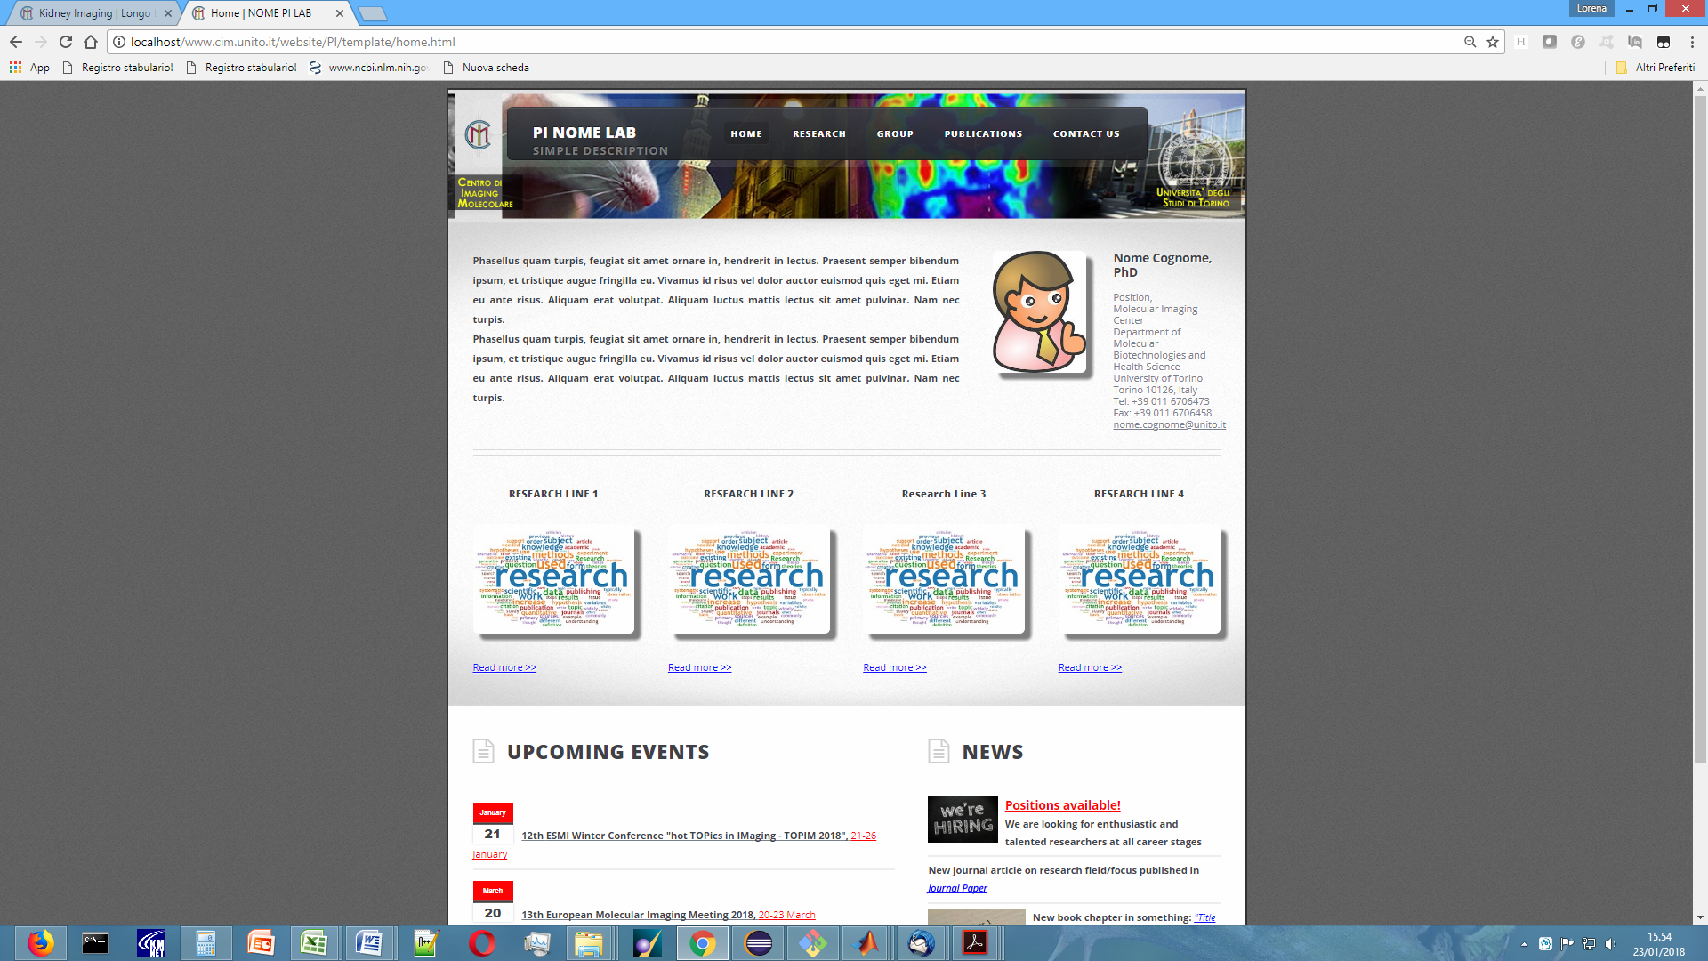

**RESEARCH OVERVIEW**

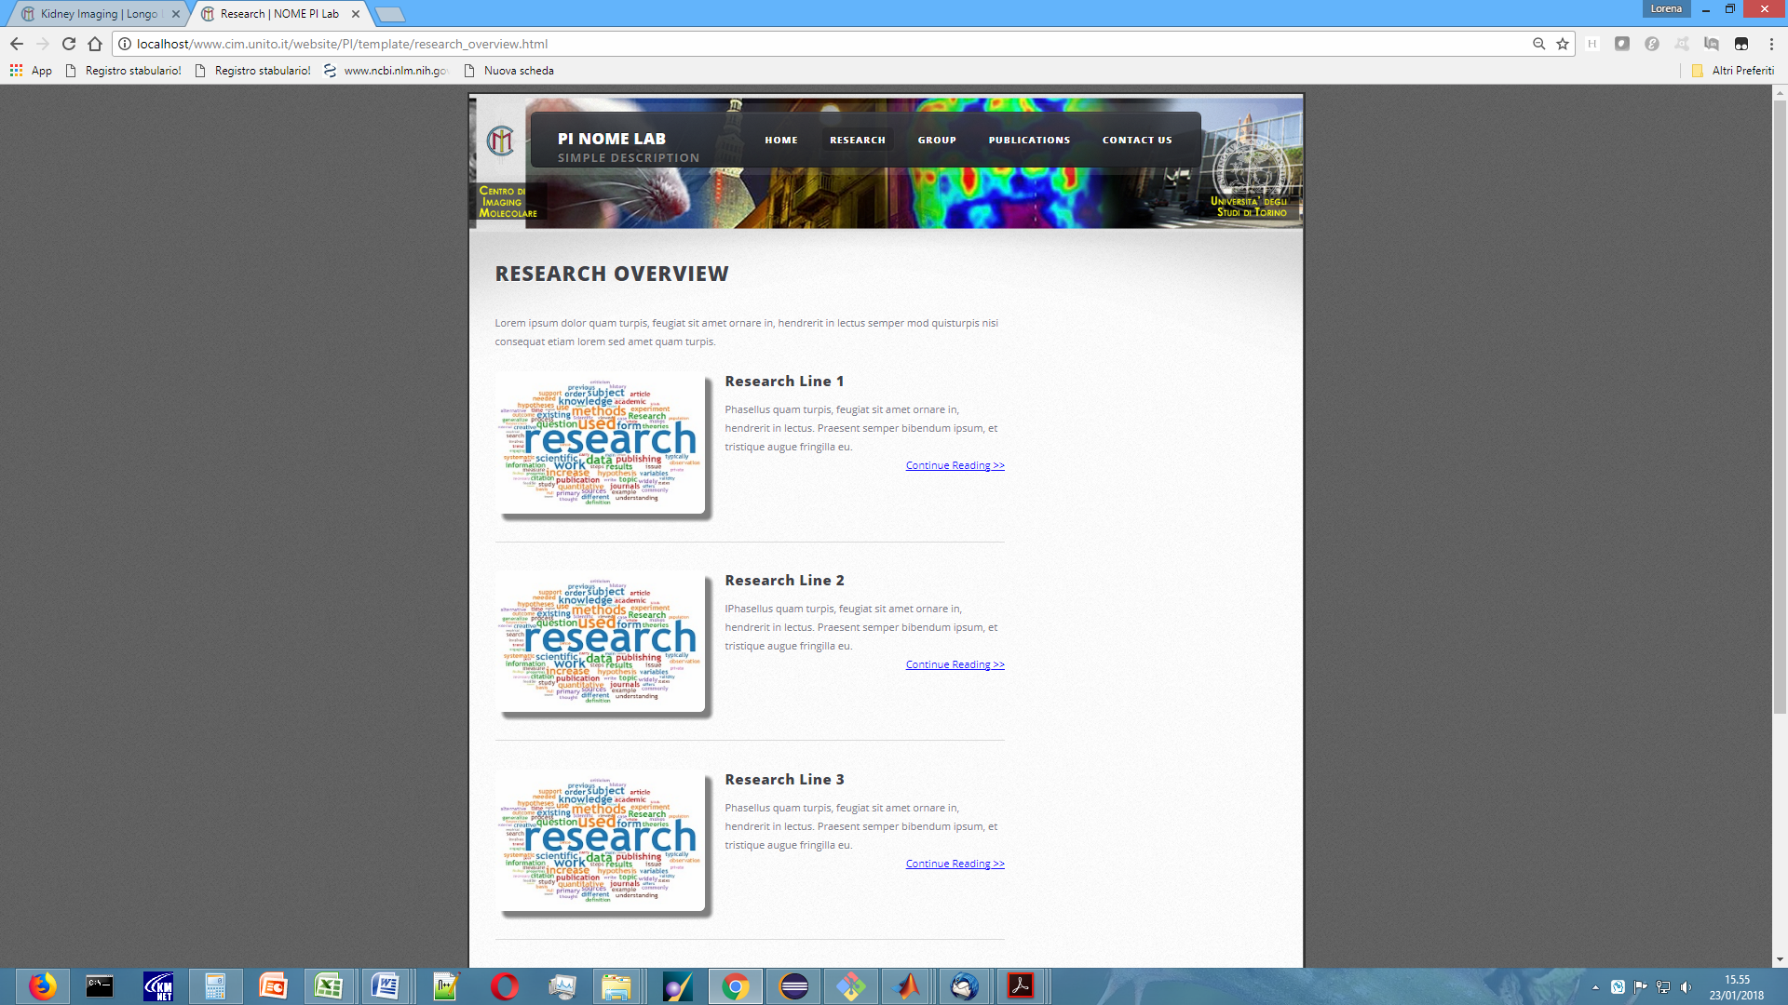

**RESEARCH LINE #1, #2, ...**

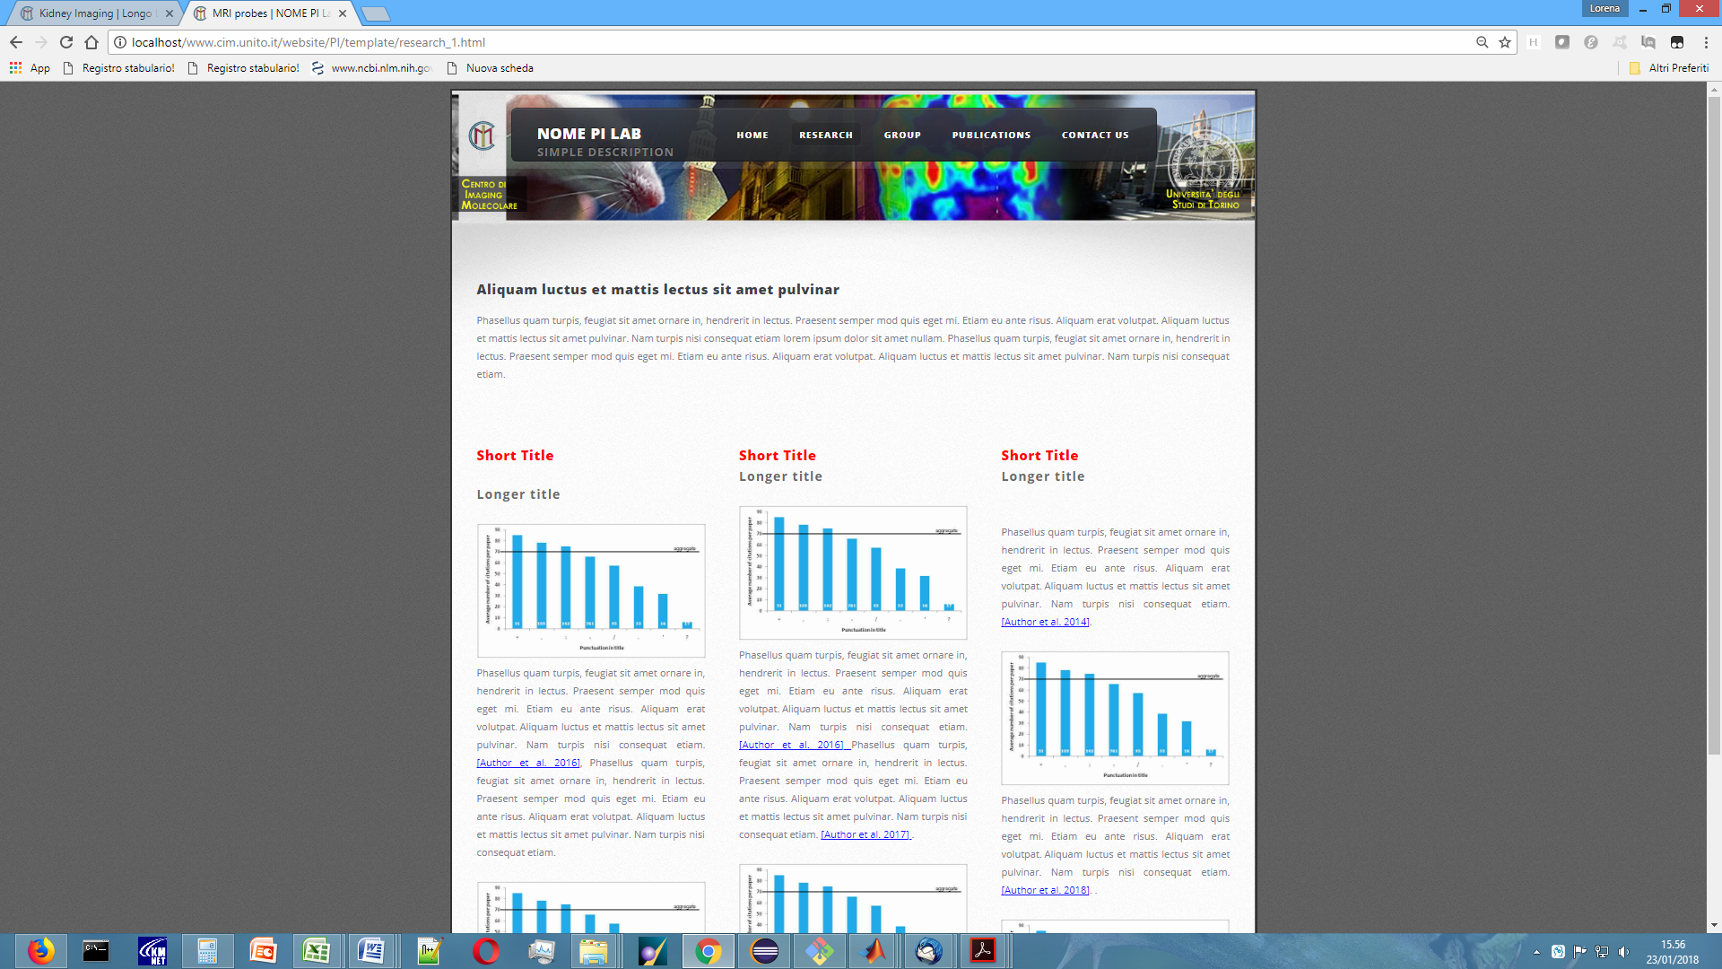

**GROUP**

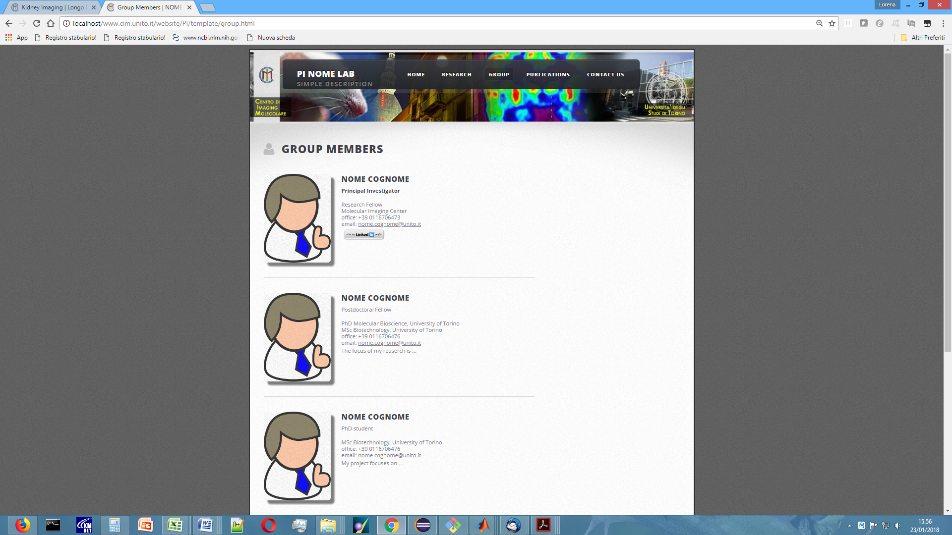

**PUBLICATIONS**

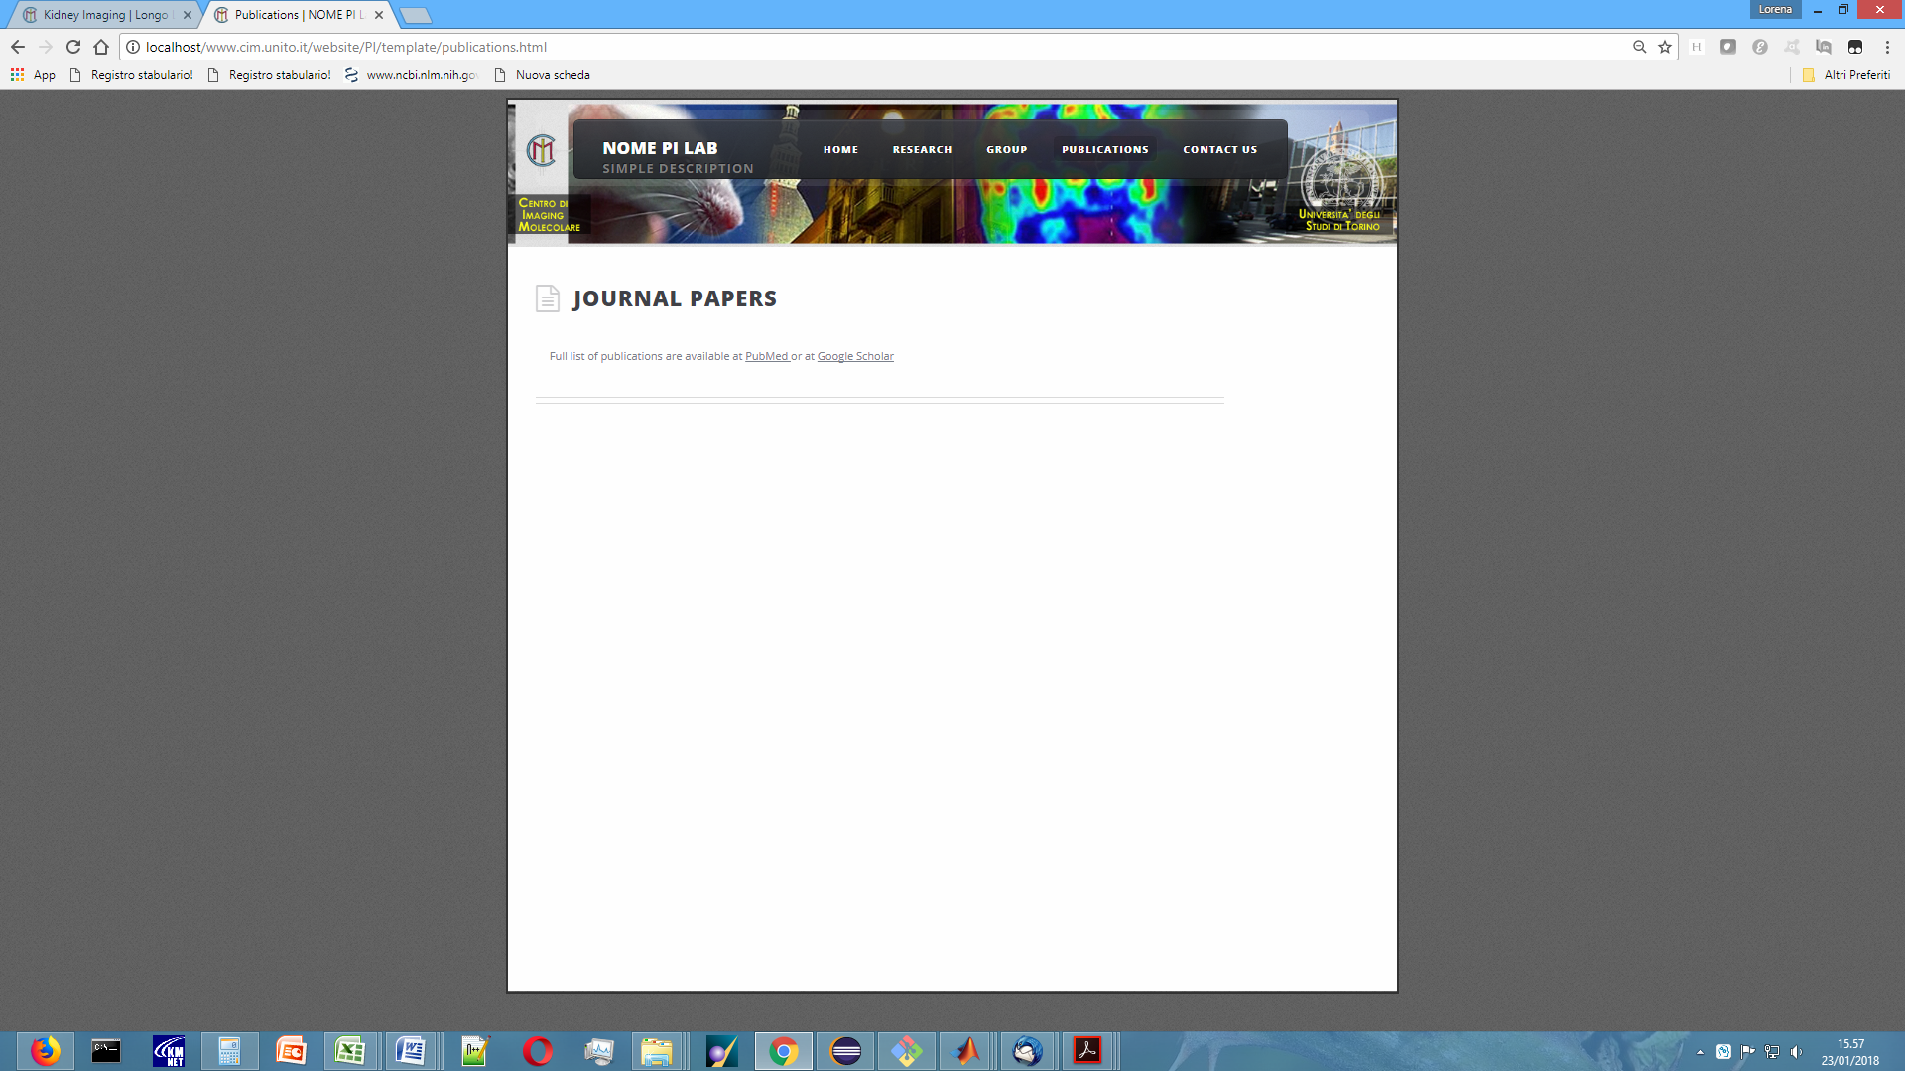

**CONTACT US**

